**Wi-Fi configuration**

**ESP8266 SHEILD**

**Adding ESP8266 Board in Arduino IDE**

1. **Goto “file”**
2. **Select “preference”**
3. **Copy “http://arduino.esp8266.com/stable/package_esp8266com_index.json”**

**and paste in additional board manager section.**

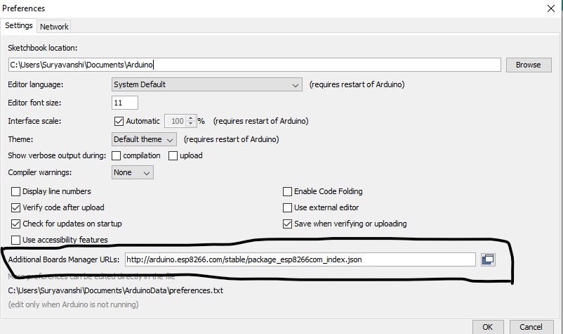

1. **Goto Board manager and search for “ESP8266” and install it.**
2. **In Board Manager, you got the option of ESP8266 Board.**
3. **Select ESP8266 board and com port and upload the code.**

**Source Code**

#include <ESP8266WiFi.h> //https://github.com/esp8266/Arduino

//needed for library

#include <DNSServer.h>

#include <ESP8266WebServer.h>

#include <WiFiManager.h> //https://github.com/tzapu/WiFiManager

#define trigger 14

#define LED 12

#define power 3

void setup() {

// put your setup code here, to run once:

Serial.begin(115200);

pinMode(trigger,INPUT);

pinMode(LED,OUTPUT);

pinMode(power,OUTPUT);

if(digitalRead(trigger) == HIGH){

digitalWrite(power,HIGH);

WiFiManager wifiManager;

wifiManager.resetSettings();

wifiManager.autoConnect("Electro-Med WiFi Manager");

Serial.println("connected :)");

}

}

void loop() {

if (WiFi.status() == WL_CONNECTED)

{

digitalWrite(power,LOW);

while(WiFi.status() == WL_CONNECTED){

digitalWrite(LED,HIGH);

delay(500);

digitalWrite(LED,LOW);

delay(200);

}

}

else {

digitalWrite(LED,LOW);

}

}

Reference

https://circuitdigest.com/microcontroller-projects/using-wifi-manager-on-nodemcu-to-scan-and-connect-wifi-networks